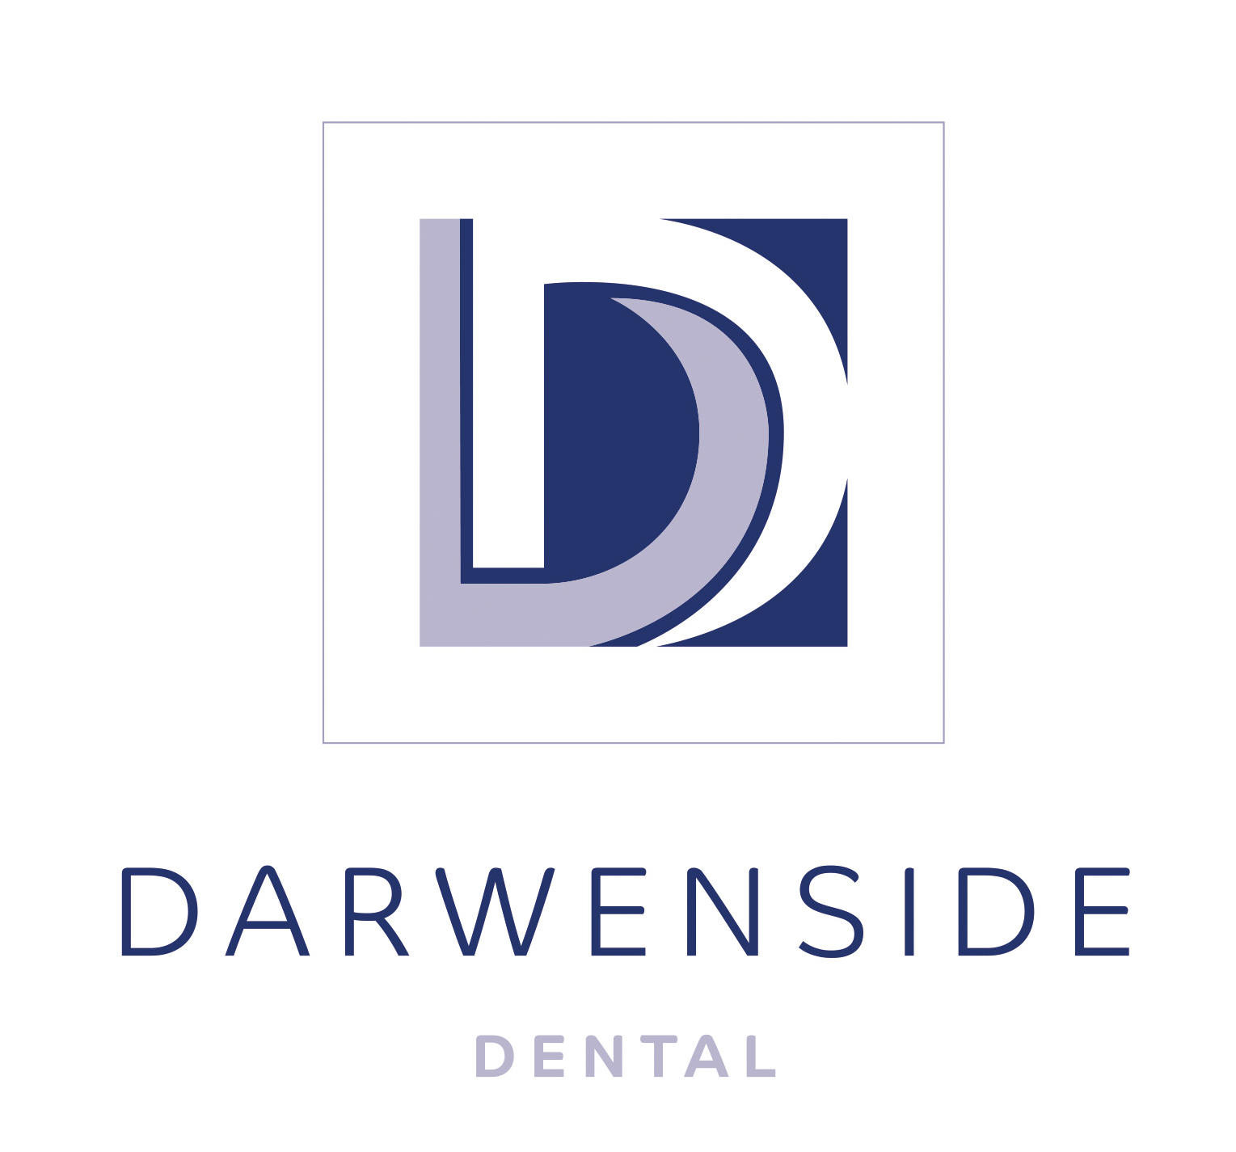 | Union Street  Darwen  BB3 0DA  Phone: 01254 703020  Email: enquires@darwendental.co.uk

CONFIDENTIAL PATIENT QUESTIONNAIRE
NAME: ______________________________________________________________________________
DATE OF BIRTH: _______________________________________________________________________
Details of person to contact in an emergency:
Name: ________________________________________ Phone: _______________________________
Relationship: __________________________________________________________________________

MEDICAL HISTORY
Doctors Name: _______________________________________________ Phone: _________________
Surgery Address: _______________________________________________________________________

1 Are you receiving any medical treatment the present time? Yes/No
Details: ___________________________________________________________________________
2. Have you been a patient in hospital during the past two years? Yes / No
Reason: ___________________________________________________________________________
3. Have you taken any medicine tablets, capsules or drugs during the past two years? Yes / No
Details: ___________________________________________________________________________
4. Have you experienced any allergies or unusual effects from any tablets, drugs, injections or anaesthetic? Yes / No
Details: ___________________________________________________________________________
5. Are you, or have you been, under the care of a doctor during the past two years? Yes / No
Reason: ___________________________________________________________________________
6. Have you ever had any of the following? If so, please tick as appropriate.
 | Rheumatic Fever |  | Epilepsy
 | Heart Trouble |  | Anaemia
 | High Blood Pressure |  | Diabetes
 | Asthma |  | Kidney Trouble
 | Arthritis |  | Gastric Problems
 | Hepatitis - Specify type A, B, C |  | Cold Sores
 | Bronchitis or Chest Problems |  | Depressive Illness
 | Severe Headaches |  | Drug Dependence
7. Have you had any prosthetic surgery? (E.g. Heart Valve or Hip Replacement) Yes / No
Details: ___________________________________________________________________________
8. Woman, Are you pregnant? If so, how many months: _____________________ Yes / No
9. Are you HIV positive or are you at risk of HIV exposure? ___________________________________ Yes/No
10. Do you smoke? If so how many per day? _________________________________________________ Yes/No
11. Do you drink alcohol? If so how many units per day? _______________________________________ Yes/No
DENTAL HISTORY
1. Name of Last Dentist: _______________________________________________________________
2. Approximate date of last dental visit:
Details: __________________________________________________________________________
3. Do you have Dental pain or a Dental problem at present? Yes / No
Details: __________________________________________________________________________
4. Have you ever experienced excessive bleeding or bruising from dental treatment, cuts or scratches? Yes / No
5. Do you become anxious or uncomfortable when you are having dental treatment? Yes / No

EXEMPTIONS
Do you receive any benefits? Yes/No If yes, which benefit do you receive? _________________________
PLEASE BE AWARE THAT PROOF IS NEEDED AT EVERY APPOINTMENT.

Signed: Patient/Parent/Guardian _____________________________________ Date: _______________

PLEASE BRING A LIST OF ANY MEDICATION YOU TAKE TO YOUR FIRST APPOINTMENT. THANK YOU

